**AIM- To create a Docker image**

**Go to terraform scrip in C Drive , create a folder docker in it then open in command line**

**Crate a .tf file with this name and context**

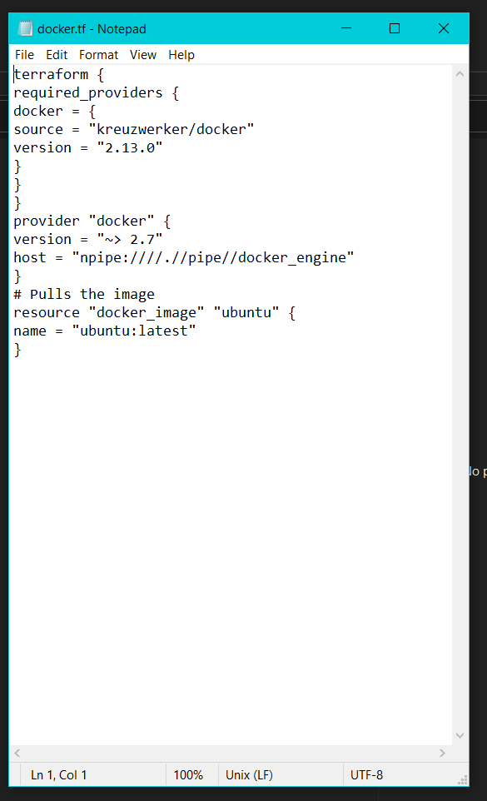

**To the same path, type the following commands-**

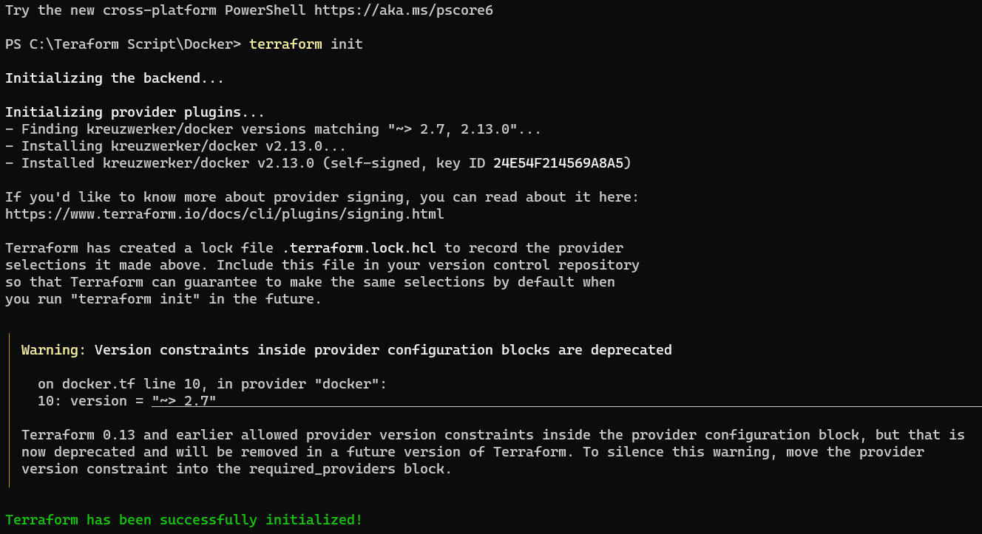

**Now simply follow the below commands**

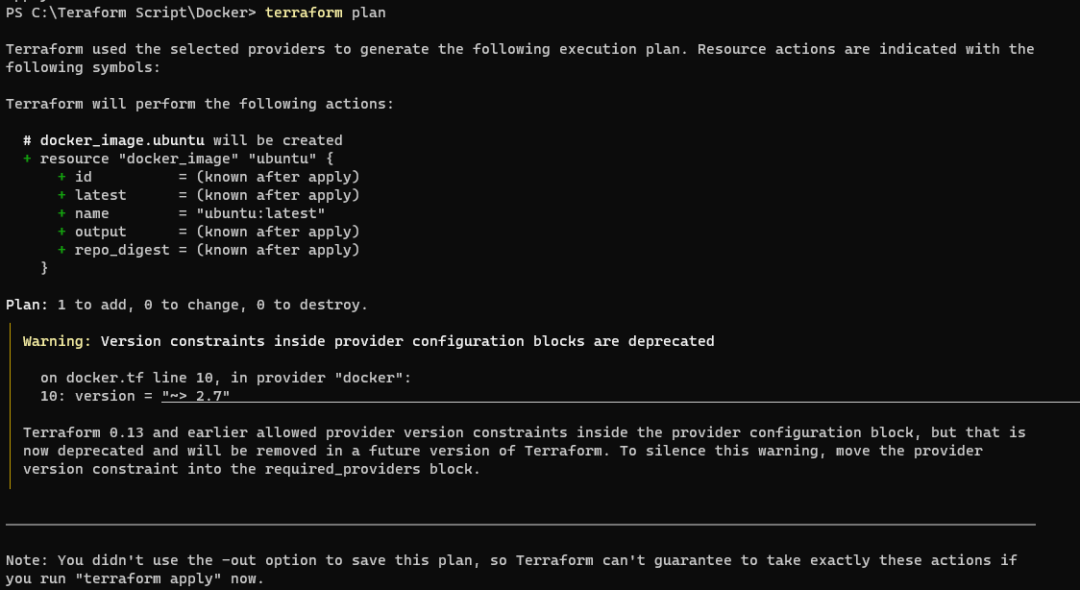

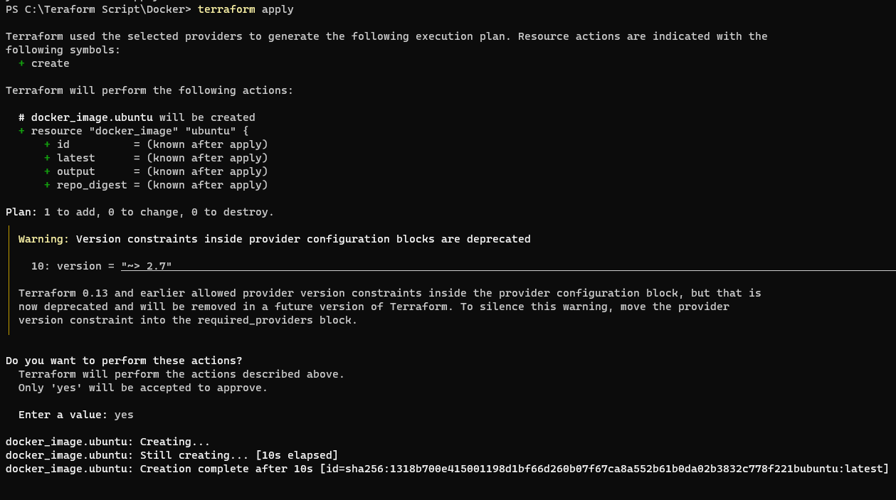

**Check for docker image**

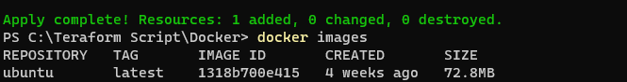

**Destroy docker**

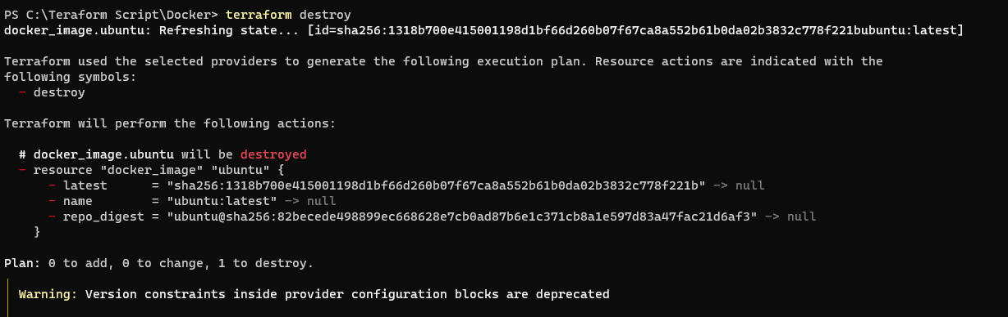

**Check for docker image again-**

